**A Project Report**

**On**

**Library Management System**

Submitted in partial fulfilment of the requirements for the award of degree of

**Bachelor of Business Administration (Computer Application)**

**Submitted By:**

**Aryaman Kamat**

**&**

**Soffin Kotadiya**

Academic Year: 2022– 2023

**Submitted to:**

**Savitribai Phule Pune University**



Shree Chanakya Education Society

**Indira College of Commerce and Science, Pune**

**Vice Principal & (H.O.D) Guided By**

**Prof. Shivendu Bhushan Prof. Shubhangi Chavan**

**Index**

|  |  |  |  |
| --- | --- | --- | --- |
| Sr. No |  | Particulars | Page No. |
| 1 |  | Abstract | 4-5 |
| 2 |  | Introduction |  |
|  | 2.1 | Motivation | 6 |
|  | 2.2 | Problem statement | 6-7 |
|  | 2.3 | Purpose/Objectives/goals | 7 |
|  | 2.4 | Literature survey | 7-8 |
|  | 2.5 | Project Scope and Limitations | 8-9 |
| 3 |  | System Analysis |  |
|  | 3.1 | Existing System | 10 |
|  | 3.2 | Scope and Limitation of existing system | 10-11 |
|  | 3.3 | Project perspective, features, stakeholders | 11 |
|  | 3.4 | Requirement Analysis | 11-12 |
|  | 3.4.1 | Functional Analysis | 12-13 |
|  | 3.4.2 | Performance Analysis | 13 |
|  | 3.4.3 | Security Analysis | 14 |
| 4 |  | System Design |  |
|  | 4.1 | Design constraints | 15-21 |
|  | 4.2 | System Model | 22 |
|  | 4.2.1 | Data Flow Diagram | 23-24 |
|  | 4.2.2 | Data Model | 25-26 |
|  | 4.3 | User Interface | 27-34 |
| 5 |  | Implementation Details |  |
|  | 5.1 | Software and hardware specifications | 35 |
| 6 |  | Output and Report Testing |  |
|  | 6.1 | Test Plan | 35-36 |
|  | 6.2 | Black Box Testing/Data validations Test cases | 36 |
|  | 6.3 | White Box Testing/functional validations Test cases and results | 37-38 |
| 7 |  | Conclusion and Recommendation | 38-39 |
| 8 |  | Future Scope | 39 |
| 9 |  | Bibliography and References | 39 |

**Acknowledgement**

We would like to express our sincere and heartfelt gratitude to our institution” Indira College of Commerce and Science” which provided us with excellent opportunity to achieve our most cherished goal in life to become Bachelor degree in BBA-CA.

We are extremely grateful to our respected Vice Principal and HOD Prof, Shivendu Bhushan for providing excellent academic environment which has made this endeavour possible.

We take this opportunity to express our deep sense of gratitude to our guideProf. Shubhangi Chavan for their resplendent idea and constant encouragement in making this project unmitigated success. Their thoughtfulness and understanding was vast and thoroughly helpful in successful completion of project. Our sincere thanks to all our faculties and non-teaching staff for their at most co-operation.

Finally we proudly thank our parents and friends for their constant support and priceless guidance in throughout this endeavour.

Aryaman Kamat

Soffin Kotadiya

**1.ABSTRACT**

The advent of diverse information technology systems has revolutionized the way of doing things. A majority of business solutions are automated to meet the changing needs of the end users. Information systems have proved to be effective in implementing the business processes of most organizations and institutions across the globe.

Library Book Management System is an online application that was developed and designed with the sole objective of automating library services. This system aimed at automating the processes of cataloguing, book circulation, fine calculation, card processing, member details maintenance, and reports generation.

A number of tools were used to implement this system. They include: PHP scripting language, HTML5, Cascading Style Sheets, MySQL database running on Wamp Server, Bootstrap and Microsoft visual studio code.

In reference to this system’s objectives, a fully automated library book management system was developed using the mentioned tools. The system’s performance meets user’s requirements, hence providing the main benefit of concentrating all the library services and functions within the power of a mouse click and feeding of data into the system.

The objective of the **“Library Management Software”** is to handle the entire activity of a library. The software keeps track of all the information about the books in the library, their cost, their complete details and total number of books available in the Library. The user will find it easy in this automated system rather than using the manual writing system. The system contains a database where all the information will be stored safely. The system is user-friendly and error free.

Thisproject is helpful to track all the book and library information and to rate the maximum number of books, the visitors wished to read. The software will be able to handle all the necessary information.

The library management system is used for management of records. The records include books which are required by different students accordingly. Maintaining these records manually becomes difficult thus we are proving such system a computerized backend. In this system each member is provided with a member code and all the records are maintained in a table along with the member’s code. Any information can be accessed according to member-code anytime from the table and also at the time of issuing books.

**2. Introduction**

**2.1. Motivation**

Accelerated technological advancements experienced in the 21st century have enabled automation of services delivered to the people across the globe. Currently, many libraries have embraced the trend of automating their services by providing rich electronic resources for research and other purposes to the public. My motivation to develop this system came from the increased need to access resources over the internet for purposes of research, increased information technological advancements that enables service automation, and the governments drive to digitize resources for extensive research in both public and private universities. The vast knowledge and skills acquired during the past four years of my study at USIU also motivated me to develop a system that provides a solution to a problem.

**2.2. Problem Statement**

The current system is operated manually. A membership form has to be filled with all the members’ details and signed duly. The form is submitted alongside the membership registration fee. The librarian staff enters this information in the all member’s records book. A temporary note is issued to the member as he/she waits for the official membership card. Librarian checks through the book records to find out its availability before a member can borrow it. A member can borrow a book by producing their cards which are retained until they return the book. Librarian notes the borrow date and due date on the book card. A fine is calculated on return of the book. This fine is calculated manually. The manual system poses a number of challenges which include:

* It wastes a lot of time.
* It’s difficult to process large volumes of information concerning books.
* Fines are calculated manually hence accuracy is not guaranteed.
* There is no backup for the records hence in case of any exposure to danger, all information gets lost.
* A lot of paper work is involved hence more room and staff to handle them which translates to more costs; making the system expensive.
* It’s difficult to search where a book is sectioned in the library and its availability.

**2.3. Project Objectives**

This system has a number of objectives:

• To develop a system that ensures the privacy of its users and enable them access it remotely.

• To enable easy maintenance of members and book details.

• To enable easy retrieval of books by simply searching the system.

• To design a system that responds in a timely manner.

• To enable easy borrowing and returning of books.

• To enable automated fine calculation and reports generation.

• To enable a secure and portable database system that eliminates duplicate data.

• To ensure a paperless environment.

**2.4. Literature survey**

This reviews information about the Library Management Systems that have already been researched and developed together with the various approaches used by these systems. Online journals, articles, publications and books were used to provide information on this topic.

Libraries across the world present a conducive environment where people converge to do their research and study. Majority of these libraries are situated within the facilities of learning institution. These libraries play an important role in the entire operation of an institution.

The Library Book Management System has been developed with the aim of improving services delivered to its users. This is made possible by automating all the library services. The system was developed after evaluating the legacy system which had not automated a majority of its functions. User requirements were gathered so as to determine the relevant functionality that was needed. This evaluation acted as a management tool to measure the effectiveness of services delivered to the library users and to identify disadvantages of the system and the most appropriate way forward.

Book lending systems were created way back in the past centuries even before the computer age. The French book wheel invention enabled scholars to circulate books by stepping on a pedal that turned a book table. Albert Cotgreave developed the book indicator back in 1863. It housed smaller versions of the books making it possible to tell the availability of the book, or if it was overdue. Automation of libraries began in 1930’s. This is when the punch card systems were used to manage book acquisition and circulation. (Gapen, 1993) Notes; virtual library comprises aspect of remotely accessing services and content of other libraries, alongside other resources of information. The internet acts as a powerful tool through which materials can be made available for sharing and access by anyone across the globe. Libraries have accumulated resources that can provide a good source of information for research and other use. Making these rich resources available to the general public across the globe is of great advantage. The aim of technological advancements is to make work easier and ensure efficiency is realized in all facets of life where it’s applicable.

(Aswal, 2006) Notes; that library automation is the process of interconnecting systems to enable the sharing of information through networks hence providing access to large volumes of content and information to users across the globe. The use of the internet and networking has been emphasized a lot. A library needs the latest technology been used in the 21 century, hence, institutions need to phase out legacy systems, and embrace automation of all their services.

**2.5. Project Scope**

The scope of Online Library Management System includes:

* Create distinct users based on their roles and permissions.
* Authenticate users at their login.
* Provide the list of books the users can borrow.
* Facility to reserve books that are available.
* A status page for all users to view books reserved by them.
* A status page for all users to view books borrowed by them, their individual due dates and their individual penalties if any.
* Providing interface to add or delete books to staffs.

**2.5. Limitations**

* The drawback of a proposed system is that the Members cannot pay their fine through online and fine calculation module is quite Erroneous.
* One Member (Student and teacher) can Issue only one book at a time.
* Fine calculation Module is not implemented due to which Fine cannot be calculated for Members Book Issue.
* Once a Book is added it cannot be deleted, this module is purposely not implemented.

**3.System Analysis**

**3.1Existing System**

In the available Online Library Management System, librarian maintains the details of each book on the registers so to find out the number of books available in the library they need to go to check the entire entry which makes the process slow. While they need to spend an extra hour to maintain the records of books. For a student who wants to know about a book in the library need to search the entire book section. The student needs to check the status of the book means the last date of book, how many books has issued.

**3.2Limitations Of Existing System:**

1. Every system humans work with is vulnerable to errors made by a distracted, fatigued or incompetent team member. Automated systems still require human interaction, but reduce the number of decisions or operations a human must perform. Whether filing a patron's reserve request or tracking the arrival of new books, each step handled by a computer makes the entire system more efficient because it is less prone to mistakes.

2. Searching for a specific book in a card catalog -- the most iconic manual library system -- means moving from one index to another when you change your search from author to title. With an automated system, you can conduct any kind of search you like from the same location with a few clicks. This saves patrons time as compared to the old way, and needs less help from library employees. Because all indexes are virtual instead of physical, an automated system can have more search categories without adding another piece of furniture. Patrons can search by a wider variety of key words and concepts than with a card catalog. Automated catalogs can also be put online, letting a patron confirm a book is available from home instead of coming to the library and being disappointed.

3. Libraries and information are becoming digitalized at a rapid pace. Any library still using a manual operating system can't connect to digital resources. This makes sharing information and publications much more difficult and time-consuming than with an automated system. As the 21st century progresses and more resources become fully digital, patrons of manual libraries will be unable to access a growing percentage of information.

4. To manage all the sections of the services cost to maintain it get increased.

**3.3Project features**

* Catalog management: to digitally keep track of what is available in the library. The books will be catalogued by title, subject, author and date of publishing.
* Membership management: to maintain a detailed database of the members. The system records the name, ID and password of each user. The system helps in ascertaining the track record of the member.
* Circulation Management: to track the movement of books. The location of any book at any point of time can be tracked. Misplaced or missing books can be traced with ease. The details on books to be returned and that which are overdue for return are provided on a daily basis.
* Acquisition management: to acquire new books and add them digitally. Irrelevant and outdated books are deleted.
* Search function: to enable both the librarian and the members to search the catalog of books in the library. The search functions can be filtered to the need of each user.
* Self-management: to check in and check out books by oneself. The library management system software of digital libraries allows the members to login, search, select, issue and return books by themselves.

**3.4Requirement Analysis**

**Hardware Specification**

RAM: At least 1GB

Hard Disk: At least 80 GB

Monitor: 17-inch Colour Monitor.

Processor: 3.0 GHz Processor

Peripheral’s: Mouse and Keyboard

**Software Specification**

Operating System: Window 7, 8,10

Language: PHP Database: MySQL

Server: Wamp Server

Browser: Mozilla Firefox, Internet Explorer, Google Chrome.

**3.4.1. Functional Analysis**

* Member (Students & Teachers): -
* Login
* Member details
* Issued Books
* View Fine
* View Due dates
* Admin: -
* Login
* Manage Members account
* Manage Books
* The system shall enable the librarian to create a new user using the Add User functionality. The system shall assign users a unique username and password which allows them to access the system.
* The system shall enable the librarian to display all the users using the List Users functionality.
* The system shall enable the librarian to update or delete a user’s details.
* The system shall enable the librarian to update a member’s information using the Update Member functionality. This information comprises of all the member’s details.
* The system shall enable the librarian to add new books to the system using the Add Book functionality where he captures all the book details into the system. The system shall enable the librarian to list, delete, update, and search a book using the List Books, Delete Book, Update Book, and Search Book functionalities respectively.
* The system shall enable the librarian to add a books category to the system using the Add Book Category functionality where he captures all the books category details into the system.
* The system shall enable a member to display and search books using the Display Book and Search Book functionalities.
* The system shall enable a member to view their history where they can check their past activities and outstanding balances using the View History functionality.

**3.4.2. Performance Analysis**

* **Response**: Time The respond time to a user should be within one to two seconds from the request time.
* **Throughput**: The LBMS shall enable many users to access it concurrently. The volume of transactions will depend directly on the number of users.
* **Utilization** of Resources: The LBMS shall make use of a MySQL database that can handle close to 5000 records. The system resources shall be modified in accordance with user requirements.
* **Reliability**: The LBMS shall operate 99% of the time. This system has to be reliable due to the important role it plays, and the crucial data it handles.
* **Accuracy**: The LBMS accuracy is determined by the speed of use executed by its users.
* **Portability**: The LBMS has been developed and coded using PHP scripts. These scripts run on a windows environment via the Wamp Server. The codes can be moved from this environment to other platforms like Linux and Mac OS supporting other servers like IIS, Apache with PHP scripts installed.
* **Extensibility**: The LBMS should be expanded in the future to handle more users and books.

**3.4.3. Security Analysis**

* The Library Management System has incorporated authorization mechanisms that ensure users access the system according to the access levels granted to them. This has also ensured that certain functions are assigned to different modules hence preventing unnecessary communication between some parts of the program.

**4.System Design**

**4.1Design constraints**

**Use Case Diagram**

**Deployment Diagram**

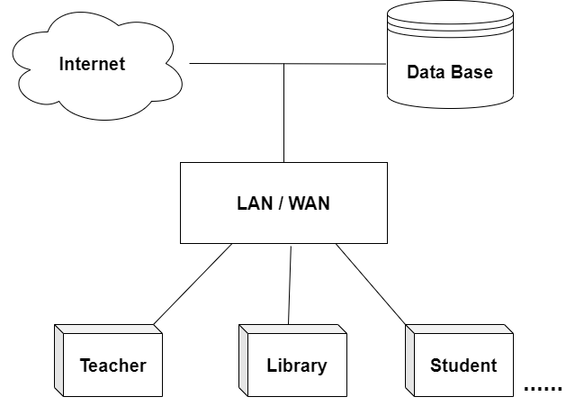

**Sequence Diagrams**

**Activity Diagrams**

no

yes

**Class Diagram**

**ERD Diagram**

**Object Diagram**

**4.2System Model**

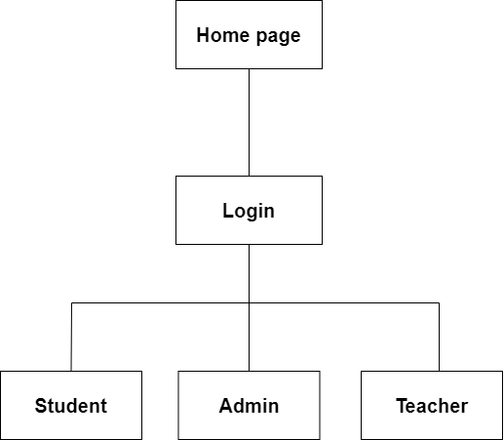

**4.2.1Data Flow Diagram**

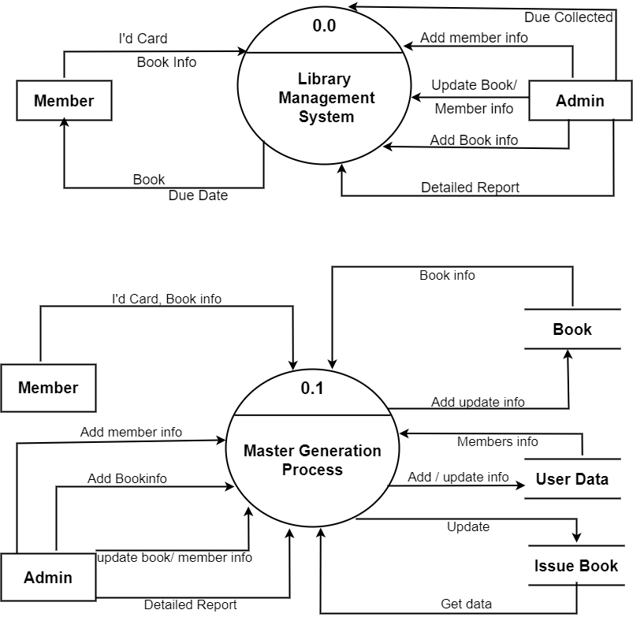

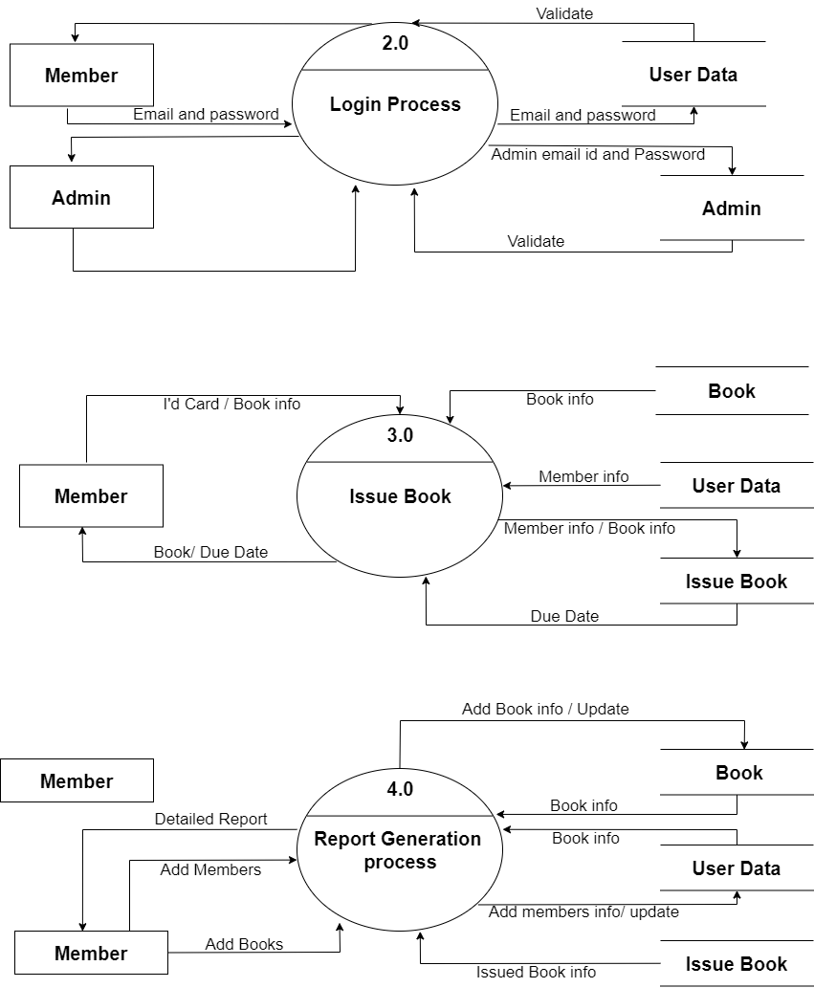

**4.2.2Data Model**

**Table Name – user**

|  |  |  |  |  |
| --- | --- | --- | --- | --- |
| **Sr.no** | **Field name** | **Datatype** | **Width** | **Constraint** |
| 1 | Id | Number | 5 | Primary key |
| 2 | name | Varchar | 20 | Not null |
| 3 | email | Varchar | 20 | Not null |
| 4 | passs | Varchar | 20 | Not null |
| 5 | type | varchar | 20 | Not null |

**Table Name – admin**

|  |  |  |  |  |
| --- | --- | --- | --- | --- |
| **Sr.no** | **Field name** | **Datatype** | **Width** | **Constraint** |
| 1 | id | Number | 5 | Primary key |
| 2 | email | Varchar | 20 | Not null |
| 3 | pass | Varchar | 20 | Not null |

**Table Name – book**

|  |  |  |  |  |
| --- | --- | --- | --- | --- |
| **Sr.no** | **Field name** | **Datatype** | **Width** | **Constraint** |
| 1 | id | Number | 5 | Primary key |
| 2 | bookpic | varchar | 20 | Not null |
| 3 | bookname | Varchar | 20 | Not null |
| 4 | bookdetail | varchar | 30 | Not null |
| 5 | bookauthor | Varchar | 20 | Not null |
| 6 | bookpub | Varchar | 30 | Not null |
| 7 | branch | Varchar | 20 | Not null |
| 8 | bookprice | Number | 10 | Not null |
| 9 | bookquantity | Number | 10 | Not null |
| 10 | bookavl | Varchar | 20 | Not null |
| 11 | bookrent | Number | 10 | Not null |

**Table Name – requestbook**

|  |  |  |  |  |
| --- | --- | --- | --- | --- |
| **Sr.no** | **Field name** | **Datatype** | **Width** | **Constraint** |
| 1 | Id | Number | 5 | Primary key |
| 2 | Userid | Number | 5 | Foreign key |
| 3 | Bookid | Number | 10 | Foreign key |
| 4 | Username | Varchar | 20 | Not null |
| 5 | Usertype | Varchar | 20 | Not null |
| 6 | Bookname | Varchar | 20 | Not null |
| 7 | issuedays | Varchar | 20 | Not null |

**Table Name – Issuebook**

|  |  |  |  |  |
| --- | --- | --- | --- | --- |
| **Sr.no** | **Field name** | **Datatype** | **Width** | **Constraint** |
| 1 | Id | Number | 5 | Primary key |
| 2 | Userid | Number | 5 | Foreign key |
| 3 | Issuename | varchar | 20 | Not null |
| 4 | Issuebook | varchar | 20 | Not null |
| 5 | Issuetype | varchar | 20 | Not null |
| 6 | Issuedays | varchar | 20 | Not null |
| 7 | Issuedate | varchar | 20 | Not null |
| 8 | Issereturn | varchar | 20 | Not null |
| 9 | fine | number | 10 | Not null |

**4.3** **User Interface**

**Login Form**

(a)below shows a login form where a user inputs their unique user details required to login the system. If the user provides the correct details, he/she is logged into the system as shown in below figure.

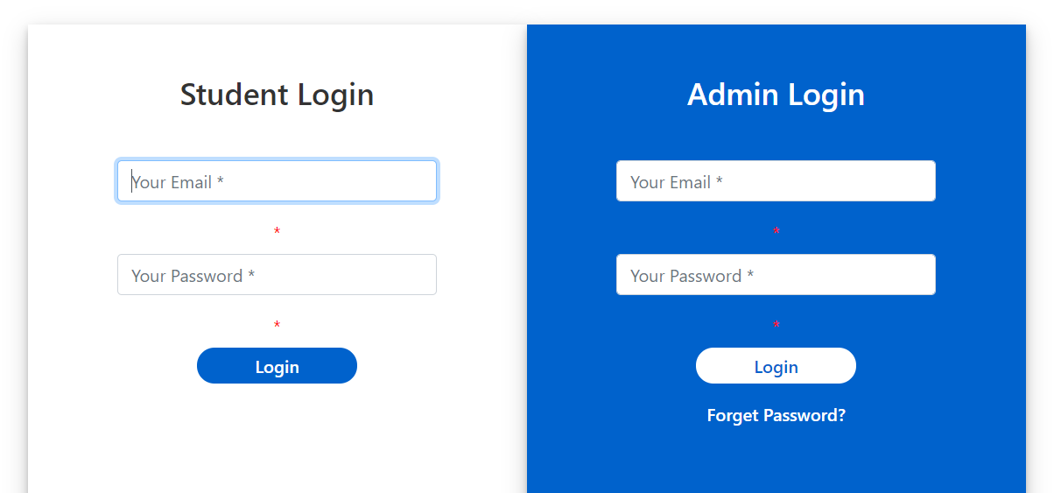

(b) If the details provided are incorrect, an error message “Invalid Credentials” is issued to the user.

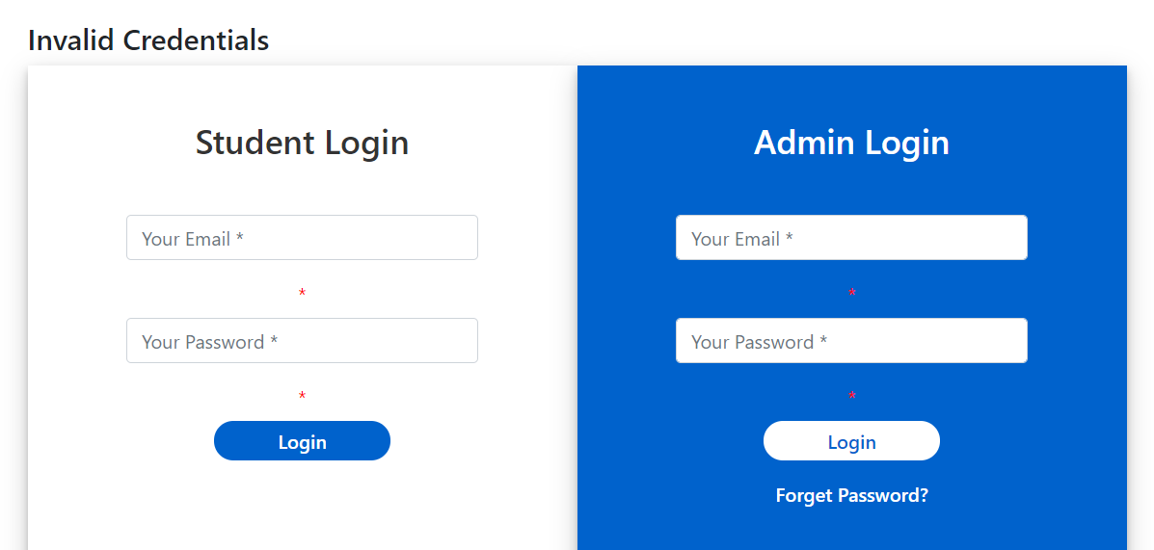

(c) Below shows the users profile which is loaded once he/she successfully logs into the system.

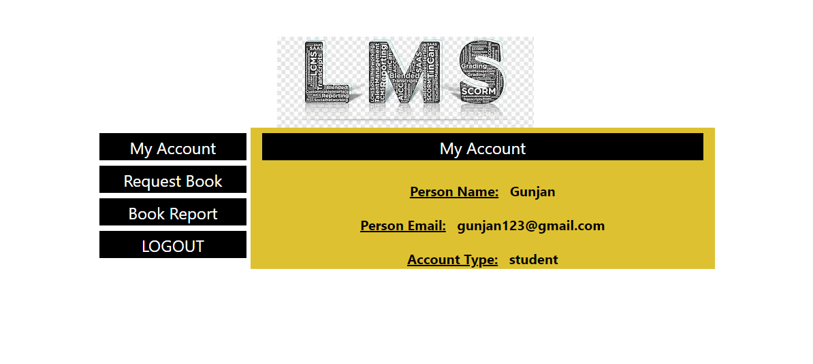

(d)Below shows the Admin logged in page.

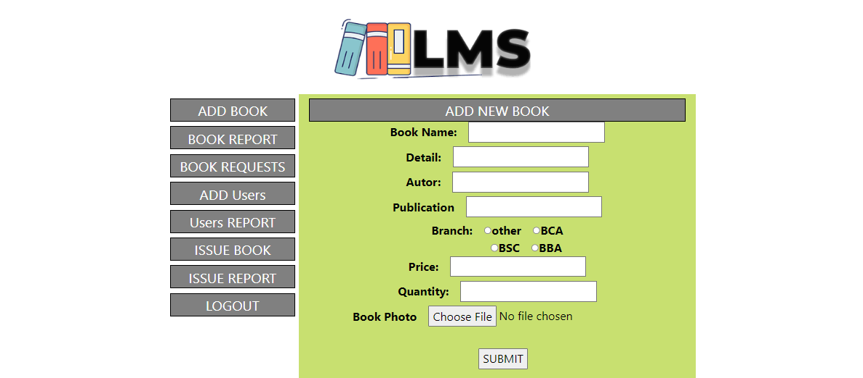

(e)**Add Book**

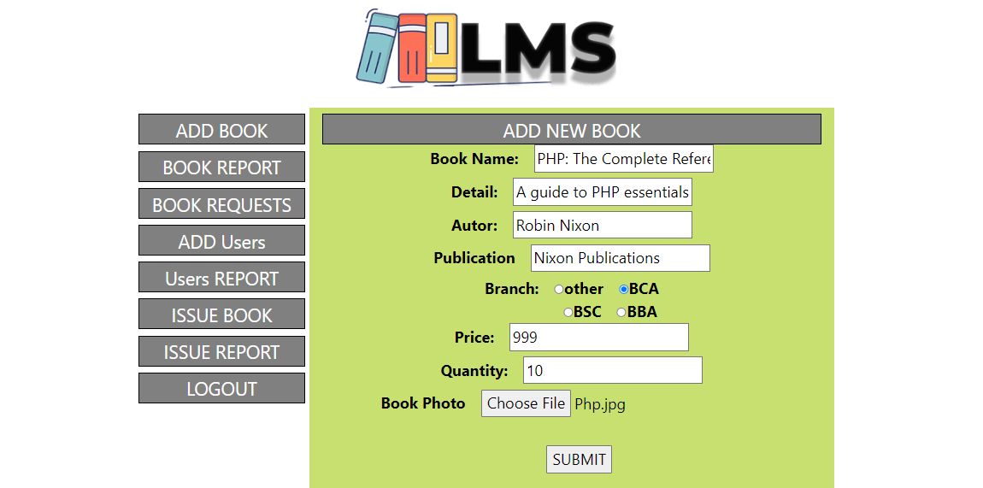

(f)**Book Added Successfully**

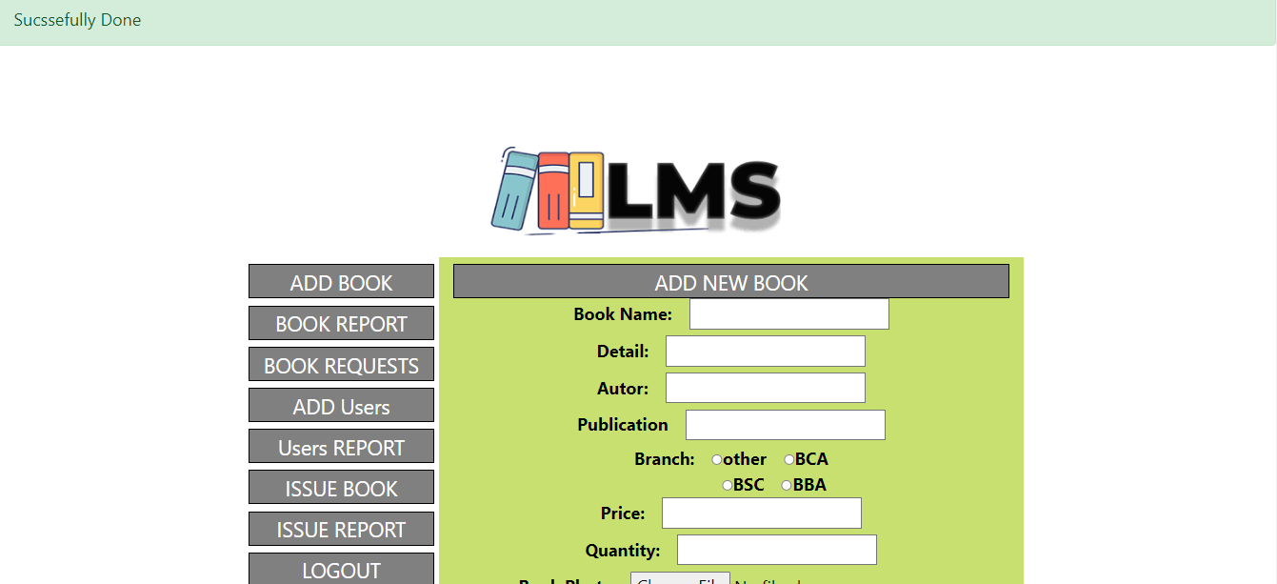

(g)**Book Report and Book Details**

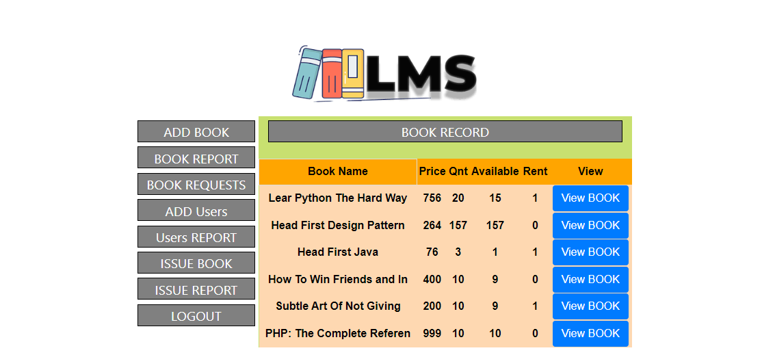

(h)**Add Users**

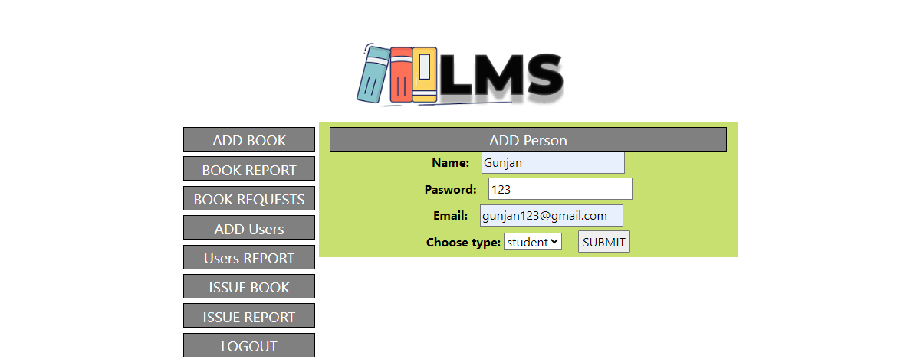

(i)**User Added Successfully**

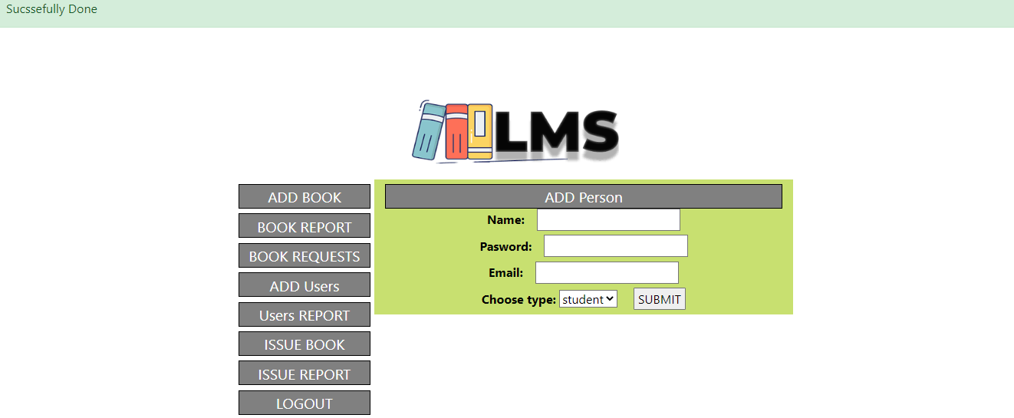

(j)**User Report**

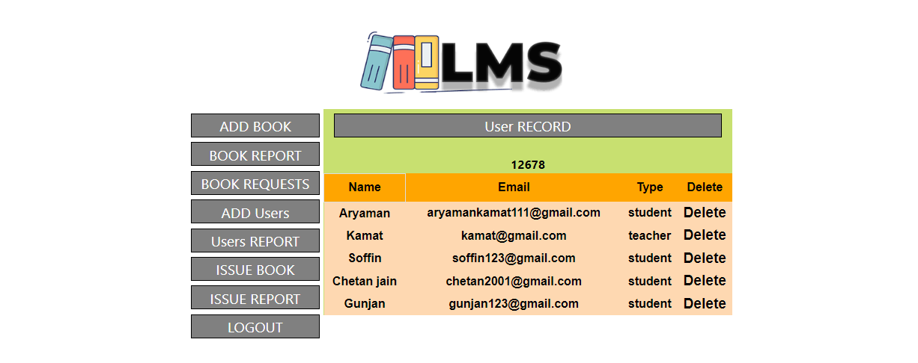

(k)**Issue Book**

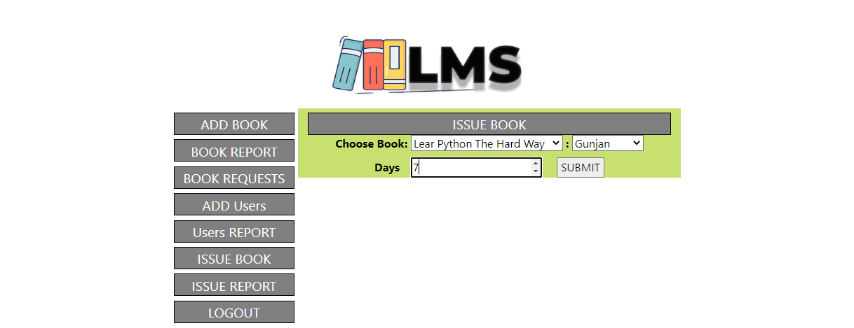

(L)**Issued Book Report**

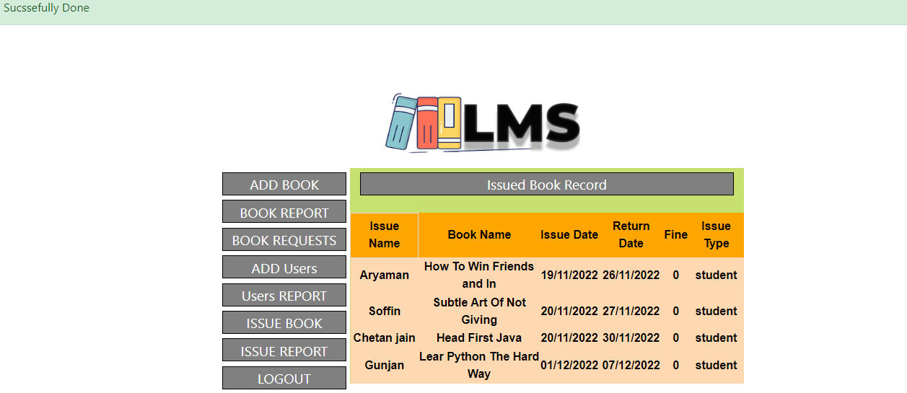

(M)**Request a Book by Student**

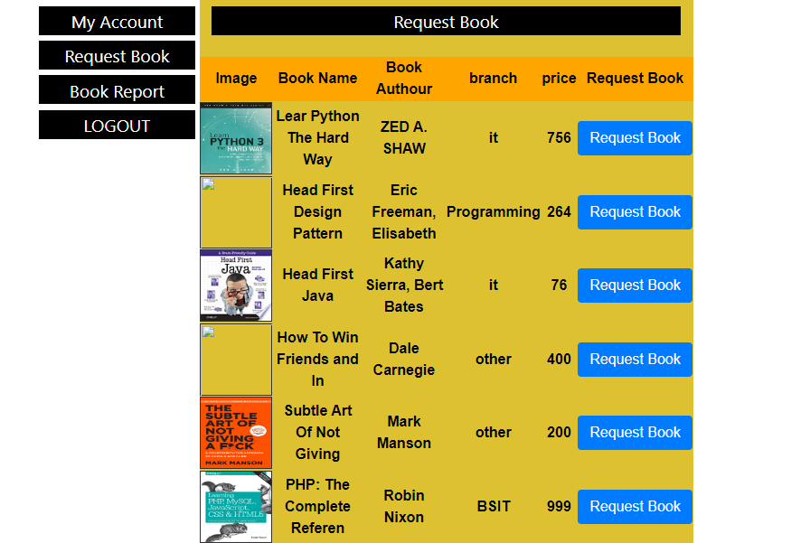

(N)**Approving the request by the Student**

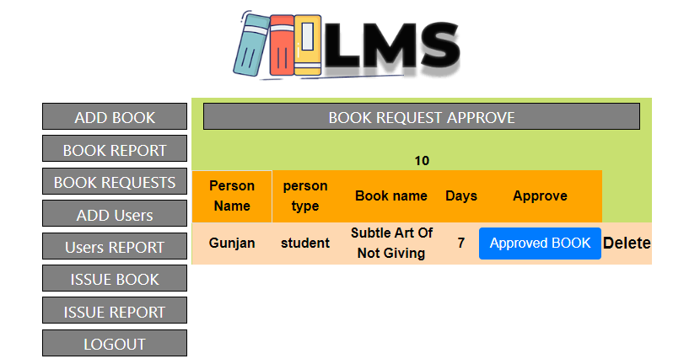

(O)**Successfully Approved the request**

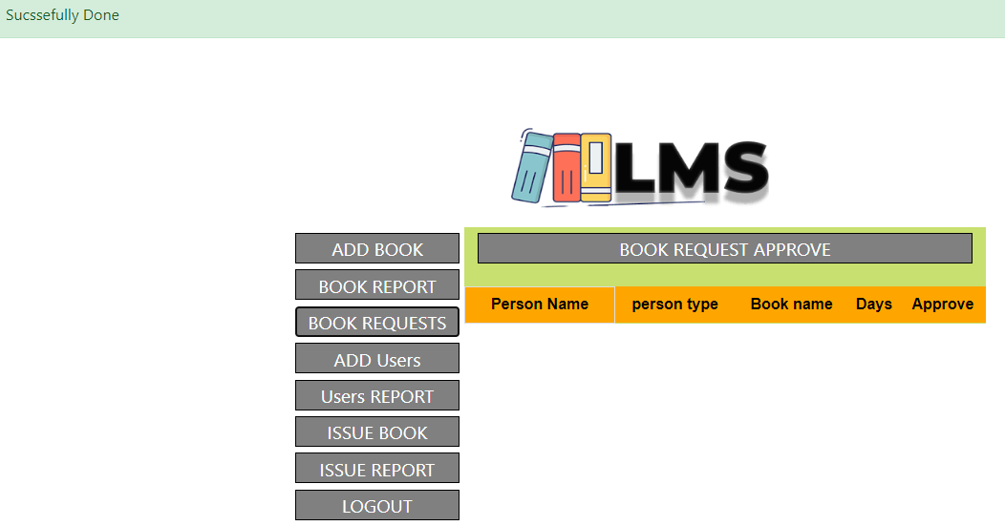

**CODE**

**Login Form code: index.php**

<!DOCTYPE html>

<html>

<head>

<meta charset="utf-8">

<meta http-equiv="X-UA-Compatible" content="IE=edge">

<title>Login Form</title>

<link href="//maxcdn.bootstrapcdn.com/bootstrap/4.1.1/css/bootstrap.min.css" rel="stylesheet" id="bootstrap-css">

<script src="//maxcdn.bootstrapcdn.com/bootstrap/4.1.1/js/bootstrap.min.js"></script>

<script src="//cdnjs.cloudflare.com/ajax/libs/jquery/3.2.1/jquery.min.js"></script>

<link rel="stylesheet" href="style.css">

</head>

<body>

<?php

$emailmsg = "";

$pasdmsg = "";

$msg = "";

$ademailmsg = "";

$adpasdmsg = "";

if (!empty($_REQUEST['ademailmsg'])) {

$ademailmsg = $_REQUEST['ademailmsg'];

}

if (!empty($_REQUEST['adpasdmsg'])) {

$adpasdmsg = $_REQUEST['adpasdmsg'];

}

if (!empty($_REQUEST['emailmsg'])) {

$emailmsg = $_REQUEST['emailmsg'];

}

if (!empty($_REQUEST['pasdmsg'])) {

$pasdmsg = $_REQUEST['pasdmsg'];

}

if (!empty($_REQUEST['msg'])) {

$msg = $_REQUEST['msg'];

}

?>

<div class="container login-container">

<div class="row">

<h4><?php echo $msg ?></h4>

</div>

<div class="row">

<div class="col-md-6 login-form-1">

<h3>Student Login</h3>

<form action="login_server_page.php" method="get">

<div class="form-group">

<input type="text" class="form-control" name="login_email" placeholder="Your Email *" value="" />

</div>

<Label style="color:red">*<?php echo $emailmsg ?></label>

<div class="form-group">

<input type="password" class="form-control" name="login_pasword" placeholder="Your Password *" value="" />

</div>

<Label style="color:red">*<?php echo $pasdmsg ?></label>

<div class="form-group">

<input type="submit" class="btnSubmit" value="Login" />

</div>

</form>

</div>

<div class="col-md-6 login-form-2">

<h3>Admin Login</h3>

<form action="loginadmin_server_page.php" method="get">

<div class="form-group">

<input type="text" class="form-control" name="login_email" placeholder="Your Email *" value="" />

</div>

<Label style="color:red">*<?php echo $ademailmsg ?></label>

<div class="form-group">

<input type="password" class="form-control" name="login_pasword" placeholder="Your Password *" value="" />

</div>

<Label style="color:red">*<?php echo $adpasdmsg ?></label>

<div class="form-group">

<input type="submit" class="btnSubmit" value="Login" />

</div>

<div class="form-group">

<a href="#" class="ForgetPwd" value="Login">Forget Password?</a>

</div>

</form>

</div>

</div>

</div>

<script src="" async defer></script>

</body>

</html>

**5.Implementation Details**

**5.1 Software and hardware specifications**

|  |  |
| --- | --- |
| **Software Requirement** | |
| Operating System | Microsoft windows |
| **Software :-** | |
| Front –End Software | Html, Css, Bootstrap |
| Back-End Software | Php |
| **Hardware Requirement** | |
| Processer : | Intel core i3 1.80GHZ |
| RAM : | 2GB or More |
| Monitor : | LCD monitor |
| Keyboard : | Normal keyboard |
| Mouse : | Compatible mouse |

**6.Output and Report Testing**

**6.1** **Test Plan**

**Testing Login of Library System**

* Check if the username field accepts valid username and password field accepts valid password.
* Check if the wrong username and valid password allows access to any specific account.
* Check if the valid username and wrong password allows access to any specific account.
* Check if the invalid username and password triggers any warning.
* Check if the invalid credentials open the random account.
* Check if the user is logged in, allows you to logout by using the link at the bottom of the application.
* Check if the logout link function as expected.

**Testing User Management**

* Check if the member transactions are updated.
* Check if the member transactions are shown in the table with sorted column information.
* Check if the user data can be modified if you are admin.
* Check if the new user is possible to add into the system using members tab.
* Check if the user can be removed using delete member feature.

**Testing Admin Management**

* Check if the admin can view all the member transactions.
* Check if the admin can view all the books available.
* **Check if the admin can add or delete a book and members.**

**6.2Black Box Testing/Data validations Test cases**

|  |  |  |  |
| --- | --- | --- | --- |
| **Sr.no** | **Test cases** | **Excepted Result** | **Test Result** |
| 1 | Enter valid name and password and click on login button | Application should display main window | Successful |
| 2 | Enter Invalid | Application should not display main window | Successful |

**6.3** **White Box Testing/functional validations Test cases and results**

|  |  |  |  |
| --- | --- | --- | --- |
| **Sr.no** | **Test cases** | **Excepted Result** | **Test Result** |
| 1 | On the click of ADD button | At first user admin have to fill all the fields with proper data, if any Error like entering text data instead of number or entering number instead of text is found then it gives proper message otherwise Adds Records to the Database. | Successful |
| 2 | On the click of DELETE button | This deletes the details of Book and Members. | Successful |
| 3 | On the click of Book Report | Book completer details of the Books are displayed. | Successful |
| 4 | On the click of Request Book. | The book request is sent to Admin. | Successful |
| 5 | On the click of Book Request. | The Admin can see the request for the book and Approve the request. | Successful |
| 6 | On the click of Issue Report | The Admin can see the Issued Books by the Members. | Successful |
| 7 | On the click of LOGOUT. | The Admin and Members gets logged out of their profile and redirected to the login page. | Successful |

**7.Conclusion and Recommendation**

There is a need for people to take initiative to be computer literate in order to familiarize with these technologies and appreciate them. Library staffs need to undergo training in order to acquire basic skills in information technology which will enable them to use the library book managements system. Libraries across the country should embrace the trend of automating their services. This system should be extended to incorporate other modules for example the acquisition module among others, in order to be fully integrated.

The availability of new technology has enabled automation of nearly all services provided in any facet of life. The library is not an exception to this great idea; hence it comes with a good number of advantages when all the activities that take place in it are automated. New jobs will always be created as a result of automation. Staff will always be motivated to work with new automated systems, since a lot of paper work is eliminated, and functions and services are concentrated just within the power of a mouse click and input of data into the system. Costs are incurred only once; when buying the system, and training personnel. Users have the convenience of accessing the system from the comfort of their locations since its web based. Cost benefit analysis of the system also shows that it generates more revenue than expenses hence the system is economically feasible.

**8.** **Future Scope**

* The proposed project will contain an attractive Home page.
* The proposed can contain a Module by which the Members/users can issue multiple books which might belong to various categories.
* The proposed system will contain a Module which will calculate the fine for issued books.
* The proposed system will contain online payment system by which the Members can pay the fine through online platforms.

**9.** **Bibliography and References**

* www.phpgurukul.com
* www.freeprojectz.com
* [www.projecthelpline.in](http://www.projecthelpline.in)
* PHP: The Complete Reference, Book by Steven Holzner
* Learning PHP, MySQL, JavaScript, CSS & HTML5: Book by Robin Nixon